# POSTMAN Manual

# Launching POSTMAN

## Installation and Updates

### Postman native apps

Postman is available as a native app for Mac, Windows, and Linux operating system.

To install Postman, got to the [apps page](https://www.getpostman.com/apps) and click **Download** for Mac/Windows/Linux depending on your platform.

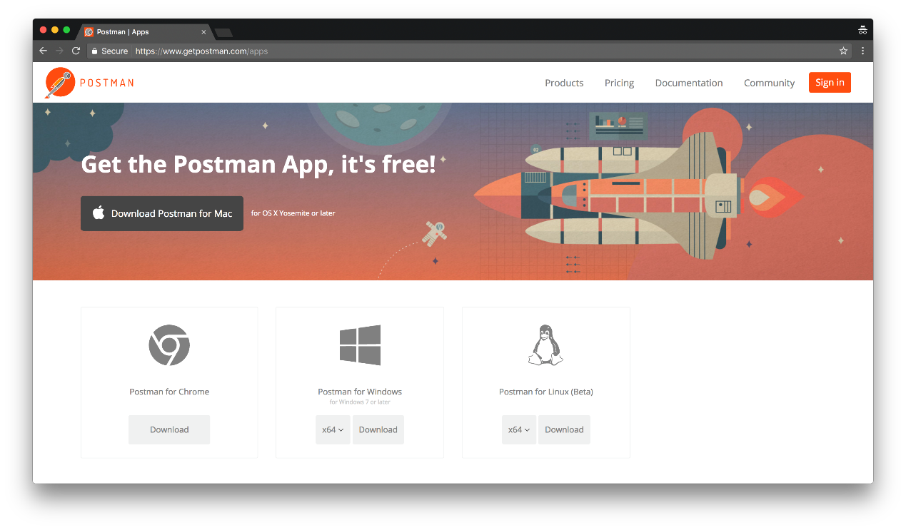**MacOS installation**

Once you’ve downloaded app, you can drag the file to the “Applications” folder. Double click on Postman to open the application

**Windows installation**

* Downloaded the setup file
* Run the installer

Linux installation

* Installation on Linux can vary between distributions. Check out this guide for installing the [Postman app on Ubuntu 16.04](https://blog.bluematador.com/posts/postman-how-to-install-on-ubuntu-1604/?utm_source=hootsuite&utm_medium=twitter&utm_campaign=).

### Postman Chrome app

We recommended using the Postman native apps, but Postman is also available as a Chrome app. Read more about [why support for the Postman Chrome app is being deprecated](http://blog.getpostman.com/2017/03/14/going-native/?_ga=2.5587509.746392084.1523253024-1663606051.1523253024).

The Postman Chrome app can only run on the Chrome browser. To use the Postman Chrome app, you will first need to [install Google Chrome](http://www.google.com/chrome/).

If you already have Chrome installed, head over to [Postman’s page](https://chrome.google.com/webstore/detail/postman-rest-client-packa/fhbjgbiflinjbdggehcddcbncdddomop?hl=en) on the Chrome Web Store, and click ‘Add to Chrome’.

The download should take a few minutes depending on your internet connection. Once you’ve downloaded the app, you can [launch Postman](https://www.getpostman.com/docs/postman/launching_postman/installation_and_updates).

### Differences between Chrome and native apps

Postman’s native apps are built on the [Electron](http://electron.atom.io/), and overcome a number of restrictions of the Chrome platform.

A few features exclusive to the native apps are listed here:

**Cookies**

The native apps let you work with [cookies](https://www.getpostman.com/docs/postman/sending_api_requests/cookies) directly. Unlike the Chrome app, no separate extension ([interceptor](https://www.getpostman.com/docs/postman/sending_api_requests/interceptor_extension)) is needed.

**Built-in proxy**

The native apps come with a built-in proxy that you can use to [capture network traffic](https://www.getpostman.com/docs/postman/sending_api_requests/capturing_http_requests).

**Menu bar**

The native apps are not restricted by the Chrome standards for the menu bar. Within the native apps, you can create collections, switch to history requests, and more.

**Restricted headers**

The latest versions of the native apps let you send headers like Origin and User-Agent. These are [restricted](https://www.getpostman.com/docs/postman/sending_api_requests/interceptor_extension) in the Chrome ap.

**Don’t flow redirects option**

This option exists in the native apps to prevent requests that return a 300-series response from being automatically redirected. Previously, users needed to use the Interceptor extension to do this in the Chrome app.

**Postman console**

The latest version of the native app also has a built-in [console](https://www.getpostman.com/docs/postman/sending_api_requests/debugging_and_logs), which allows you to view the network request details for API calls.

### Migrating to the native app

It’s simple. Sign in your Postman account after you download and started the new native app, and all your history and collections will be automatically synced.

Alternatively, if you don’t want to sign in your Postman account, you can bulk export your Postman data from the Chrome app, and then bulk import into the new native app.

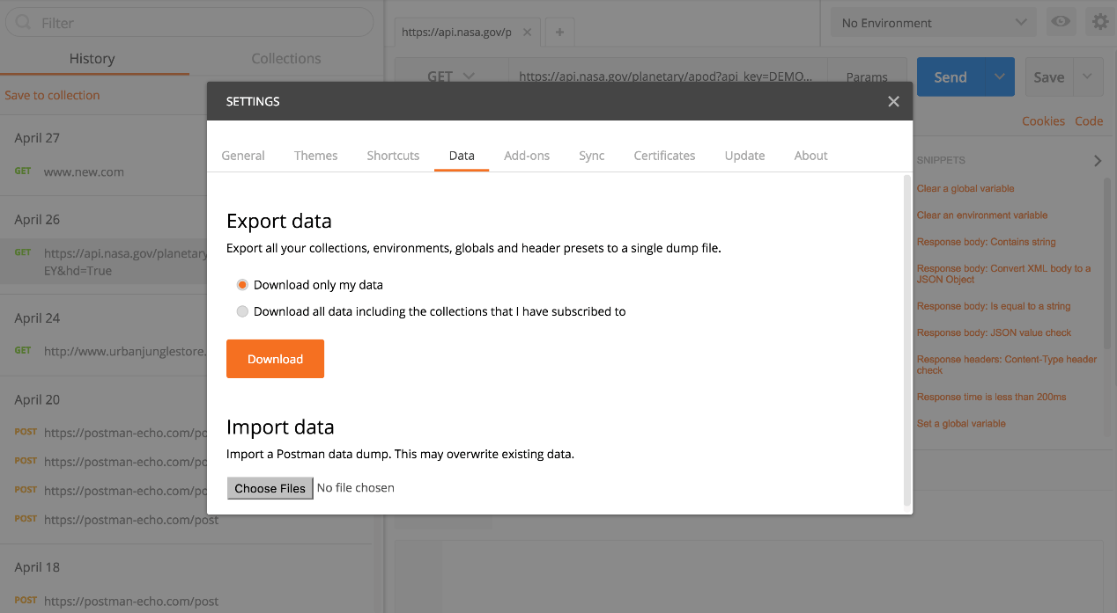

**Bulk export**

From the Postman settings, select the Data tab and click the Download button to export all your collections, environments, global and header presets to a single dump file.

**Bulk import**

From the same area in Postman settings, you can initiate a bulk from a Postman data dump file. This will overwrite your existing data so be a little careful.

### Updating Postman

**Native app (Mac, Windows and Linux)**

Postman’s native apps will check for updates whenever the app reloads, or is launched. The app will display the changelog prompting you to update the app.

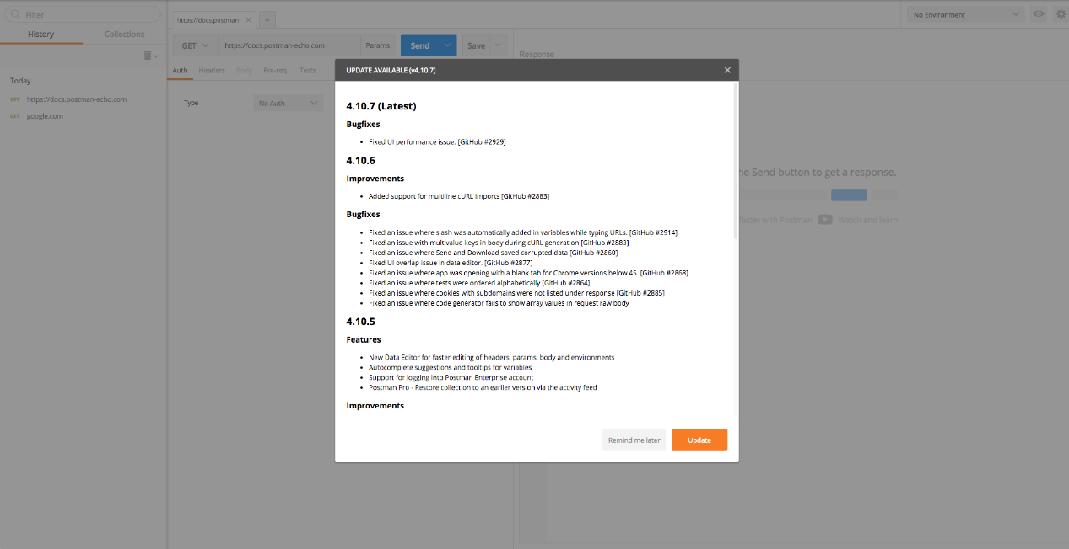

**Mac and Windows**

Click **Update** to download the latest update. You will be notified when the download is complete prompting your to restart the Postman app to apply the updates. If you’re not ready to update yet, click **Remind me later** to prompt you again after the next app reload or launch.

You can also configure your preferences to automatically download updates under the **Update** tab within the **SETTINGS** modal.

* All
* Minor fixes
* None

**All** – Downloads all updates automatically and will show a small notification at the top prompting you to restart the app to apply the updates.

**Minor fixes** – you will be notified of all major updates, and other minor fixes will automatically download prompting you to restart the app to apply the updates.

**None** – this will show up the update version every time it finds a update for your current version.

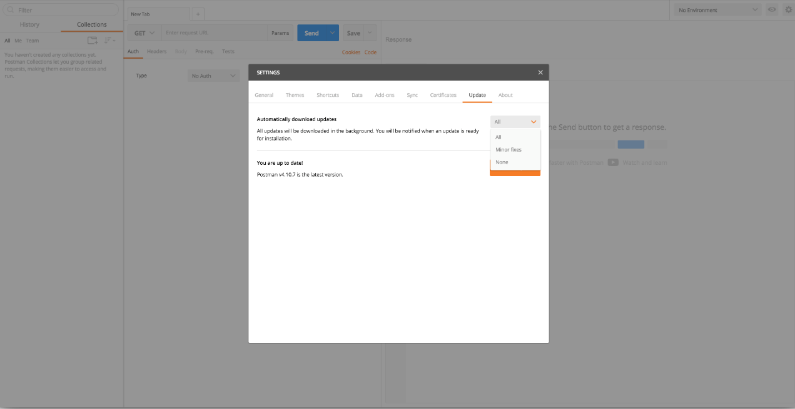

**Troubleshooting updates in MacOS Sierra**

We have received user feedback that the Mac update does not complete successful, even after downloading the update for MacOS Sierra.

This can be solved by moving the app out of the Download directory. The Postman update is unable to switch the downloaded version on the read-only memory, initially assigned for the download apps by MacOS Sierra.

If you continue experiencing difficult with the update, fetch the logs from **~/Library/Caches/com.postmanlabs.mac.ShipIt** in your system and let us know.

**Linux**

Postman’s native app on Linux will notify you whenever an update is available. If an update is available, you need to download the latest version of the application, remove the current application directory, and extract the new version. Postman stores all user data outside of the application directory, so you can safely remove the current application directory and install the new version.

Since Postman’s native apps check for updates only on app reload or launch, at any time, you can force a check for update under the **Update** tab in the **SETTING** modal of the app.

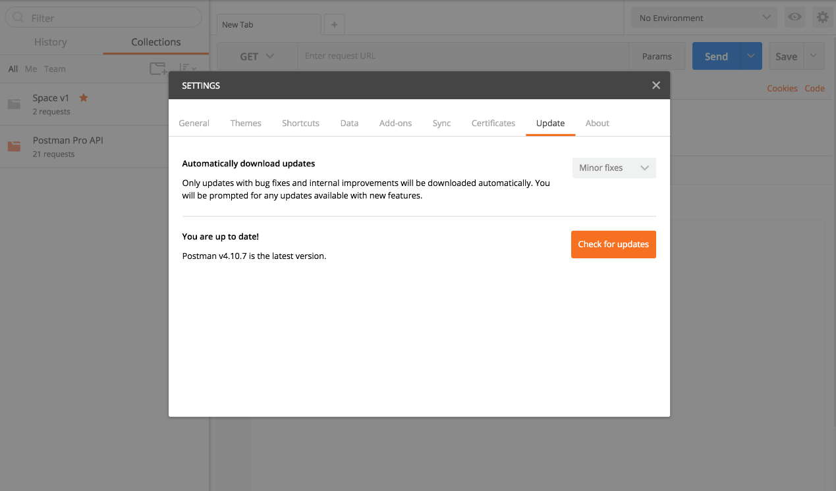

**Chrome**

Postman’s Chrome app is usually updated automatically. However, Postman doesn’t control the Chrome app update flow, and Chrome sometimes doesn’t update the app for long periods of time.

The latest version is visible of [Postman’s Web Store listing](https://chrome.google.com/webstore/detail/fhbjgbiflinjbdggehcddcbncdddomop?hl=en).

To manually force an update, here’s what you need to do in Chrome:

1. In the address bar, type chrome://extensions.
2. At the top of the page, check and enable **Developer Mode**.
3. Click the **Update extension now** button beneath **Developer Mode**.

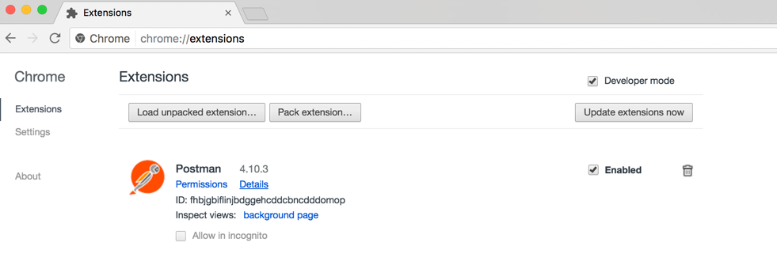

## Sending the first request

An API request lets you contact a server with API endpoints that you want to reach and perform some action. Those action are HTTP methods.

The most common methods are GET, POST, PUT and DLETE. The names of the methods are self-explanatory. For example GET enables you to retrieve data from a server. POST enables you to add data to an existing file or resource in a server. PUT lets you replace an existing file or resource in a server. And DELETE lets you delete data from a server.

Postman makes sending API requests simple. Instead of testing your APIs through a command line or terminal, we offer an intuitive graphical interface that is quick to learn and rewarding to master.

As you can see in the image below, when you enter a request in Postman and click the **Send** button, the server receives your request and return a response that Postman displays in the interface.

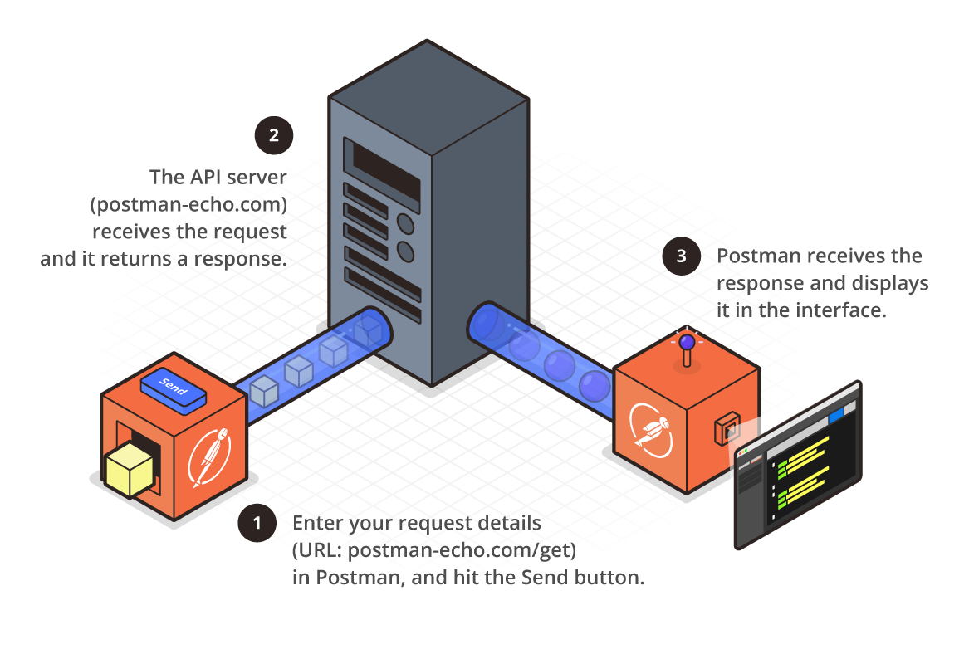

### Sending a request

Now let’s send our first API request!

Enter postman-echo.com/get into the URL field.

Click the Send button to send your request. Note the JSON data response from the server.

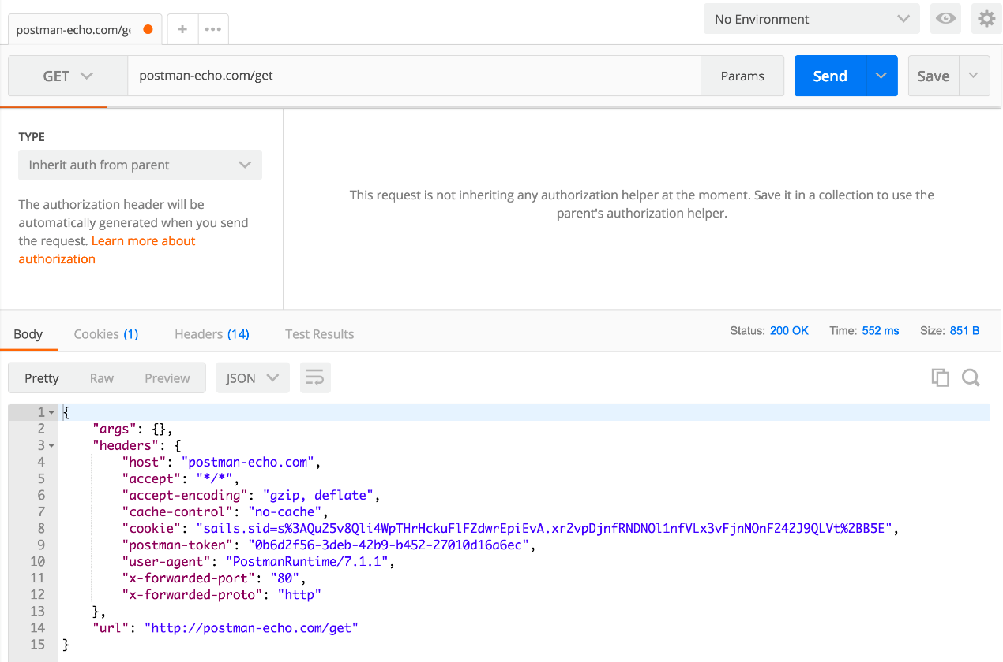

Notice that Postman adds postman-echo.com/get under the History of the sidebar. You can click the Save button to save a request to use later.

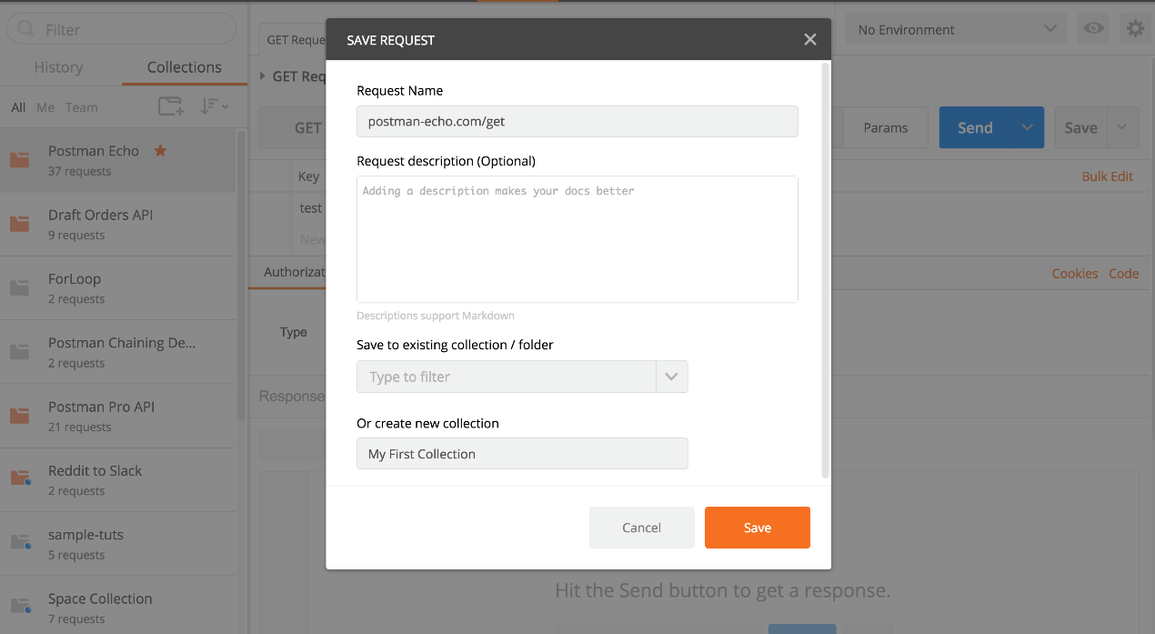

### Postman Echo

postman-echo.com is a sample API that Postman hosts for you to experiment with various types of requests. It returns the data that you send in the request as part of its response.

To learn more about Postman Echo, see the [document for this sample API](https://docs.postman-echo.com/).

For more information about request, see:

* [Requests](https://www.getpostman.com/docs/v6/postman/sending_api_requests/requests)
* [Requests History](https://www.getpostman.com/docs/v6/sending_and_viewing_responses/history)
* [Troubleshooting API requests](https://www.getpostman.com/docs/v6/postman/sending_api_requests/troubleshooting_api_requests)
* [Capturing HTTP requests](https://www.getpostman.com/docs/v6/postman/sending_api_requests/capturing_http_requests)
* [Making SOAP requests](https://www.getpostman.com/docs/v6/sending_and_viewing_responses/soap_requests)

## Creating the first collection

Postman Collections are a group of saved requests you can organize info folders.

Every request you send in Postman appears under the **History** tab of the sidebar. On a small scale, reusing requests through the history section is convenient. However, as your Postman usage scales, it can be time consuming to find a particular request in your history. Instead of combing through your history section, you can save all your requests as a group for easier access.

Let’s review hot to [send a basic request](https://www.getpostman.com/docs/v6/postman/launching_postman/sending_the_first_request) and create a new collection.

### Creating your first collection

Enter a request in the request builder and click **Save** button to open the **SAVE REQUEST** modal.

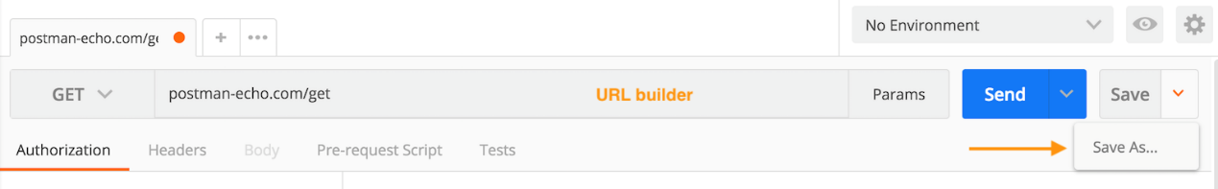

* As an optional step, enter a new request name. Otherwise, the default will be the request URL.
* As an optional step, enter a request in plain text or using [Markdown](https://www.getpostman.com/docs/v6/postman/collections/using_markdown_for_descriptions).

Save this request to an existing collection, or create a new collection by entering a collection name, and then click the **Save** button.



Congratulations! You can see all of your collections under the **Collections** tab of the sidebar on the left.

## Navigating Postman

Postman provides a multi-window and multi-tab interface for you to work on APIs.

This interface design gives you as much space as possible for your APIs.

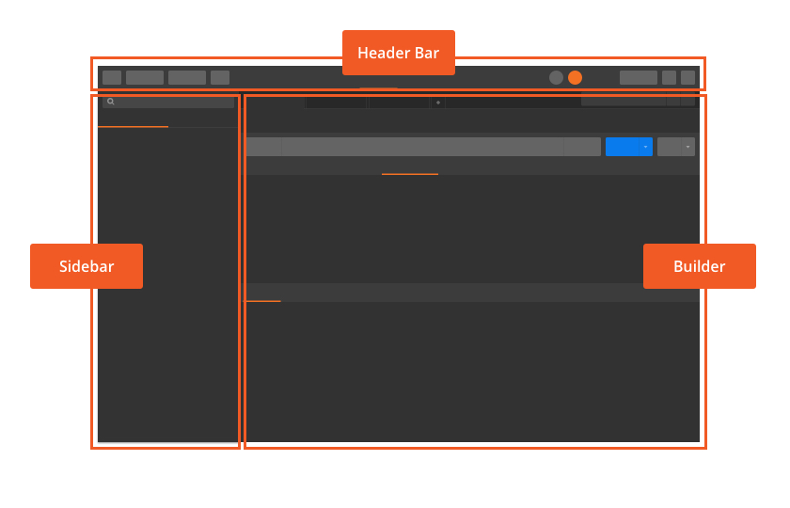

### Sidebar

The Postman sidebar lets you find and manage requests and collections. The sidebar has two main tabs: History and Collections.

You can drag the right edge to resize the width of the sidebar. You can also minimize the sidebar for smaller screen, and show or hide the sidebar in the Status bar.

### History tab

The Postman app saves every request you send in the History tab in the sidebar.

### Collections tab

This tab creates and manages collections from the **Collections** tab in the sidebar.

Learn more about collections and how they accelerate the speed of your APIs.

### Header toolbar



The header toolbar contains these options:

* **New** button: Creates requests, collections, environments, documentation, mock servers, and monitors.
* **Import** button: Imports Postman collections, environments, WADL, Swagger, RAML, or cURL into Postman using files, links or raw text.
* **Runner** button: Opens the [collection runner](https://www.getpostman.com/docs/postman/collection_runs/starting_a_collection_run).
* **New window** icon: Opens a new “Tab”, “Postman Window” or a “Runner Window”.
* **Workspace** menu: Opens the Workspace menu where you can view [personal and team Workspaces](https://www.getpostman.com/docs/postman/workspaces/intro_to_workspaces), and create and manage Workspaces.
* **Interceptor/Proxy** icon: Manages proxy or Interceptor settings.
* **IN SYNC status** icon: Updates the status of your Postman account.
* **Public API Library:** Displays the Public API network.
* **Settings** icon: Manages Postman app settings and finds other support resources.
* **Notifications** icon: Receives notifications or broadcasts.
* **Heart**: Love Postman? Click on this button to share the love!
* **User** dropdown: Displays current user and provides these options: “Profile”, “Account Settings”, “Notification Preferences”, “Active Sessions”, and “Add a new account”.

### Console

Two console are available in Postman to see what’s going on behind the scenes.

* Postman console: Contains a running log of HTTP requests and responses. You can log message from scripts. For example could log messages in the console log.

**Note**: This feature is only available in Postman’s native apps.

* DevTools console: Provides diagnostic information during development. To learn how to access DevTools console logs, see [Debugging and logs](https://www.getpostman.com/docs/postman/sending_api_requests/debugging_and_logs).

Learn more about [troubleshooting with console logs](https://www.getpostman.com/docs/postman/sending_api_requests/debugging_and_logs).

### Status bar

The status bar at the bottom of the Postman interface gives you a convenient way to:

* Show or hide the sidebar.
* Search in collections, environment, and global.
* Open the Postman console.
* Select either a single or two pan layout.
* Open the keyboard shortcuts.
* Get help or provide feedback.

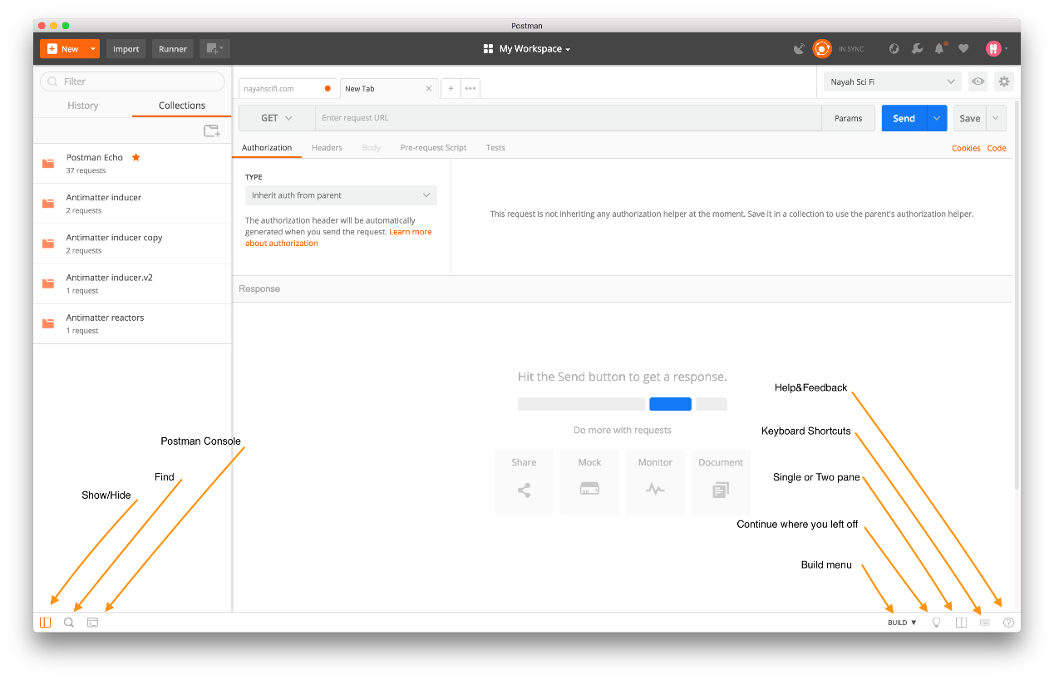

When you click the **Help & Feedback** icon, you can summon a menu that provides access to the latest release notes, documentation, security, support, and social media.

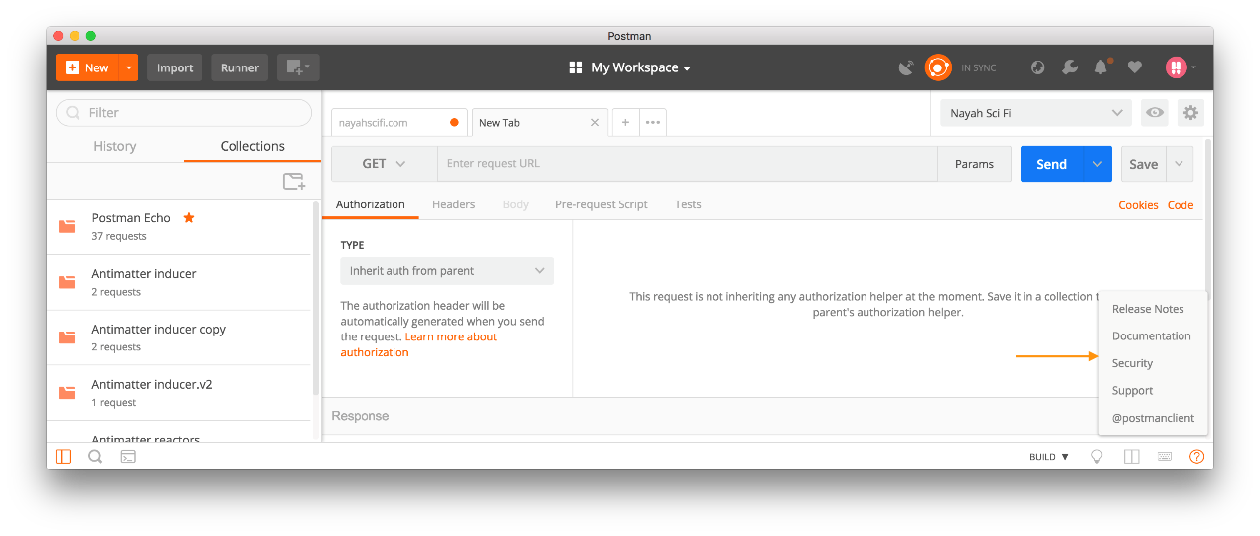

### Tabs and Windows

Postman lets you use multi-tab and multi-window configurations to work on multiple requests or even multiple collections together and simulataneously.

To open a new tab in Postman, press the **+** icon in the builder or use the **CMD/CTRL + T** shortcut. From the menu bar, you can also select “New Tab” from the **File** menu to create a new tab.

When you right click a tab name, the menu allows you to duplicate or close tabs. If any tab has unsaved changes as you attempt to close the tab, Postman prompts you to save your changes.

**Busy tabs**

Busy tabs ensure you don’t lose your current request, even if it isn’t in a collection. When you’re in a busy tab and open a new request from the sidebar, Postman opens the request in a new tab and doesn’t replace or interface with the request in the previous busy tab.

**Tab and sidebar behavior**

By default, Postman assumes you want to work on one collection request in one tab. When you open a request from the sidebar, Postman opens a new tab when an existing tab has unsaved changes. If not, the request takes over the current tab. You can always open a request in a new tab from the sidebar under the **Collections** tab. Right click a request and select “Open in New Tab”.

**Tab menu**

Postman offers several tab action to help you manage your work.

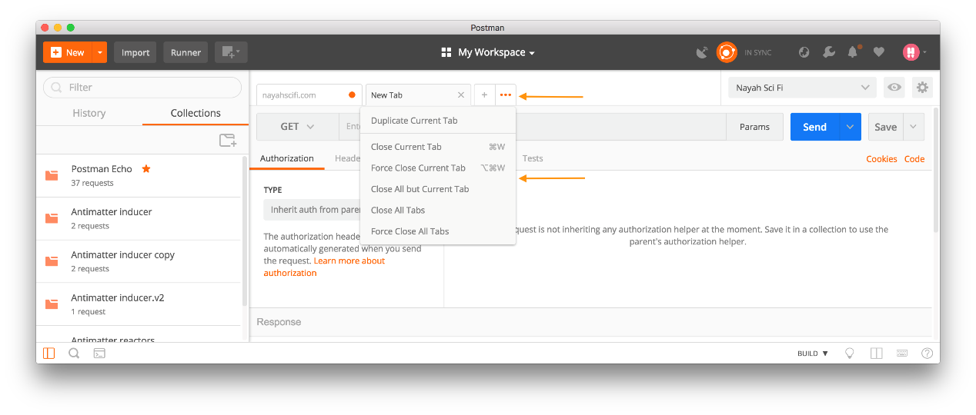

To access the Tab menu, click the three dots on the right side of a tab. A dropdown menu appears with options to manage your tabs.

* Duplicate Current Tab
* Close Current Tab
* Force Close Current Tab
* Close All but Current Tab
* Close All Tabs
* Force Close All Tabs

When you “Force Close Current Tab” or “Force Close All Tabs”, the tab closes immediately without prompting you to save your work in the tab.

When you “Close Current Tab”, “Close All but Current Tab”, or “Close All Tabs”, a dialogue box appears with an option to save your work.

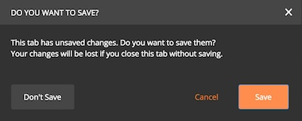

**Moving requests**

In the request builder, you can drag and drop tabs to reorder them, open a new request in a new tab, or in a new Postman window. You also can open multiple windows using the **New Window** icon in the header toolbar or the keyboard shortcut.

### Keyboard Shortcuts

Keyboard usability is a high priority for any development tool. For most developers, keyboard shortcuts are more efficient method that requires minimum movement and effort as compared to navigating with a cursor. For repetitive or frequent tasks, keyboard shortcuts improve speed over the long run.

Postman categorizes keyboard shortcuts as navigation, manipulation, and global.

* Navigational shortcuts let you move around the interface.
* Manipulation shortcuts let you manipulate the current selection.
* Global shortcuts let you access from anywhere.

**Navigational Shortcuts**

Postman designs navigational shortcuts to help you navigate quickly between elements. For example, suppose you want to open and send a series of saved requests without a keyboard shortcut. You would have to select a request in the sidebar with a pointer each time to open it in the tab.

With a keyboard shortcut, such as **CMD/CTRL + ALT + 1**. You can focus the sidebar from wherever you are in interface. You can then navigate to the request you want with the arrow keys. And if you combine the **CMD/CTRL + ALT + 1** shortcut with the **CMD/CTRL + ENTER** shortcut, you can send a number of requests quickly.